**CP Club 365Days Challenge**

**Date – 10/12/2022**

**Programming language – c++**

**Problem Statement**

**[https://practice.geeksforgeeks.org/problems/value-equal-to-index-value1330/1?page=3&category[]=Arrays&sortBy=submissions](https://practice.geeksforgeeks.org/problems/value-equal-to-index-value1330/1?page=3&category%5b%5d=Arrays&sortBy=submissions)**

**Your Code**:

// 0x54Day of 0x365Days challenge

// VEDANT BHARAD

// 10-12-2022

//{ Driver Code Starts

#include<bits/stdc++.h>

using namespace std;

// } Driver Code Ends

//User function template for C++

class Solution{

public:

    vector<int> valueEqualToIndex(int arr[], int n) {

        vector<int> retArr;

        for(int loop=0; loop<n; loop++)

        {

            if(arr[loop]==(loop+1))

            {

                retArr.push_back(arr[loop]);

            }

        }

        return retArr;

    }

};

//{ Driver Code Starts.

int main() {

    int t;

    cin >> t;

    while (t--) {

        int n, i;

        cin >> n;

        int arr[n];

        for (i = 0; i < n; i++) {

            cin >> arr[i];

        }

        Solution ob;

        auto ans = ob.valueEqualToIndex(arr, n);

        if (ans.empty()) {

            cout << "Not Found";

        } else {

            for (int x: ans) {

                cout << x << " ";

            }

        }

        cout << "\n";

    }

    return 0;

}

// } Driver Code Ends

**Output (Screen Shot)**:

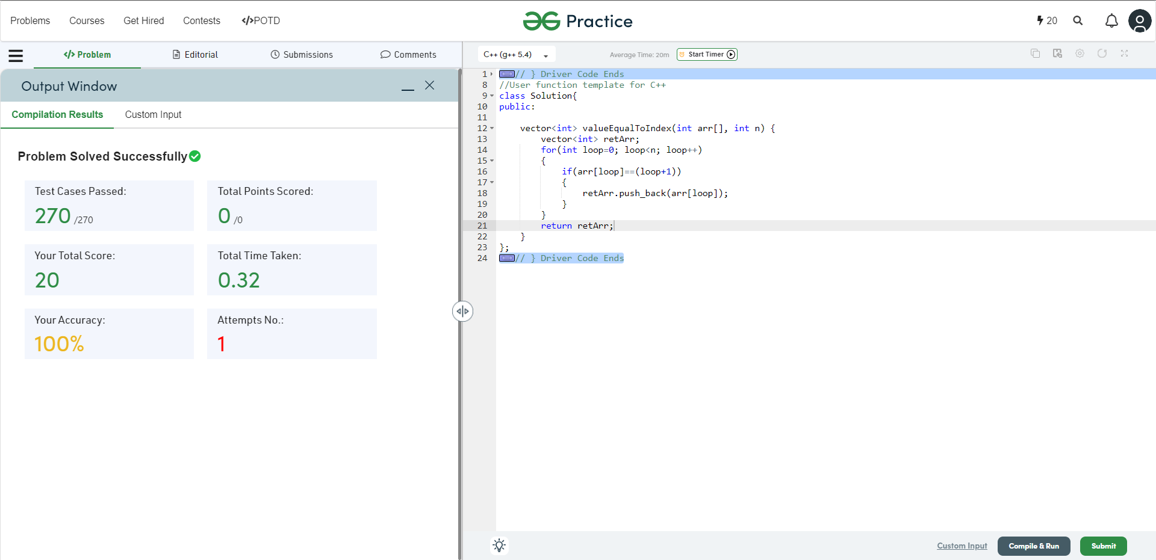

**Understanding about problem:**

* In this task I need to return one vector in which there are numbers which are same as index number in given number.

Note: If you can't understand the problem, feel free to contact us and we'll help you. Please don't copy and paste from anywhere.

ALL THE BEST

Team CP Club